Recovery Mechanism
Reflect and Retry tool plugin

The Reflect and Retry Tool plugin can help your agent recover from error responses from ADK Tools and automatically retry the tool request. This plugin intercepts tool failures, provides structured guidance to the AI model for reflection and correction, and retries the operation up to a configurable limit. This plugin can help you build more resilience into your agent workflows, including the following capabilities:

Key Features:

Concurrency Safe: Uses locking to safely handle parallel tool executions
Configurable Scope: Tracks failures per-invocation (default) or globally using the TrackingScope enum.
Extensible Scoping: The _get_scope_key method can be overridden to implement custom tracking logic (e.g., per-user or per-session).
Granular Tracking: Failure counts are tracked per-tool within the defined scope. A success with one tool resets its counter without affecting others.
Custom Error Extraction: Supports detecting errors in normal tool responses that don't throw exceptions, by overriding the extract_error_from_result method.

Configuration settings

- max_retries: (optional) Total number of additional attempts the system makes to receive a non-error response. Default value is 3.
- throw_exception_if_retry_exceeded: (optional) If set to False, the system does not raise an error if the final retry attempt fails. Default value is True.
- TrackingScope.INVOCATION: Track tool failures across a single invocation and user. This value is the default.
- TrackingScope.GLOBAL: Track tool failures across all invocations and all users.

Error Logging
Error Interception via Callbacks

ADK's robust Callback system allows developers to inject custom logic at critical points in the execution flow to intercept errors and define recovery paths.

on_model_error_callback: This function is executed when a failure occurs during a call to the underlying LLM (e.g., a 429 Too Many Requests error or a 500 error). Developers can use this to:

- Log the error and sanitize sensitive data.
- Implement custom exponential backoff and retry logic for the LLM call if the built-in model retry is insufficient.

after_tool_callback: Although designed for post-processing, developers can check the result of a tool call here. If the result is an error object, custom code can override the result (e.g., return a default value) or stop execution gracefully instead of crashing the workflow.

ADK's Checkpointing and Resumption Mechanisms

1. Resumability Configuration https://google.github.io/adk-docs/runtime/resume/
The most direct equivalent to enabling checkpointing is through the ResumabilityConfig applied to the top-level ADK application (App object).
- Mechanism: When enabled, the ADK Runtime explicitly tracks the completion state of workflow steps using Events and Event Actions.
- Checkpoint: A checkpoint is effectively created after the successful completion of a major step, such as a tool execution. The results and the Session State at that moment are persisted.
- Recovery: If the workflow stops (e.g., due to a crash or power loss), the system can be restarted and the workflow can be resumed from the partially completed state. It will reinstate the results from successfully completed tools (e.g., Tool A and Tool B) and re-run the last failed step (e.g., Tool C).
How it Works
The Resume feature works by logging completed Agent workflow tasks, including incremental steps using Events and Event Actions, tracking completion of agent tasks within a resumable workflow. If a workflow is interrupted and then later restarted, the system resumes the workflow by setting the completion state of each agent. If an agent did not complete, the workflow system reinstates any completed Events for that agent, and restarts the workflow from the partially completed state. For multi-agent workflows, the specific resume behavior varies, based on the multi-agent classes in your workflow, as described below:
- Sequential Agent: Reads the current_sub_agent from its saved state to find the next sub-agent to run in the sequence.
- Loop Agent: Uses the current_sub_agent and times_looped values to continue the loop from the last completed iteration and sub-agent.
- Parallel Agent: Determines which sub-agents have already completed and only runs those that have not finished.
Event logging includes results from Tools which successfully returned a result. So if an agent successfully executed Function Tools A and B, and then failed during execution of tool C, the system reinstates the results from the tools A and B, and resumes the workflow by re-running the tool C request.

2. Session and State Persistence
The ADK's Session Service is the backbone for checkpointing any multi-turn conversation.
- Session Object: The Session object is the definitive record of the conversation. It contains:
  - events (History): The chronological sequence of all messages, agent actions, and tool calls/results. This is the full conversational trace.
  - state (Working Memory): A key-value dictionary that stores dynamic, serializable data relevant to the current task (e.g., a flight number, an order ID, or a structured output from a prior step).
- Persistence: For checkpointing to work reliably, the default in-memory SessionService must be replaced with a persistent implementation:
  - DatabaseSessionService: Stores session data in a relational database.
  - VertexAiSessionService: Stores session data securely and scalably on Google Cloud, often using the Vertex AI Agent Engine, which is the recommended method for production.
- Resumption: By providing the unique Session ID and Invocation ID, the ADK Runner retrieves the complete event history and the last saved state from the persistent store, allowing the agent to effectively pick up the conversation exactly where it left off.

3. Custom Agent Checkpoints
For complex, multi-step Custom Agents, developers can implement explicit checkpoints:
- Custom State: Developers can create a CustomAgentState class to define the exact data structure needed to preserve the agent's internal progress.
- Explicit Saving: Within the custom agent's execution logic, the developer modifies the session.state and signals the Runner to save the agent state after each completed milestone, acting as a manual checkpoint.
Evaluation in ADK
What to Evaluate
- Trajectory and Tool use -> ground truth vs actual steps
- Final Response
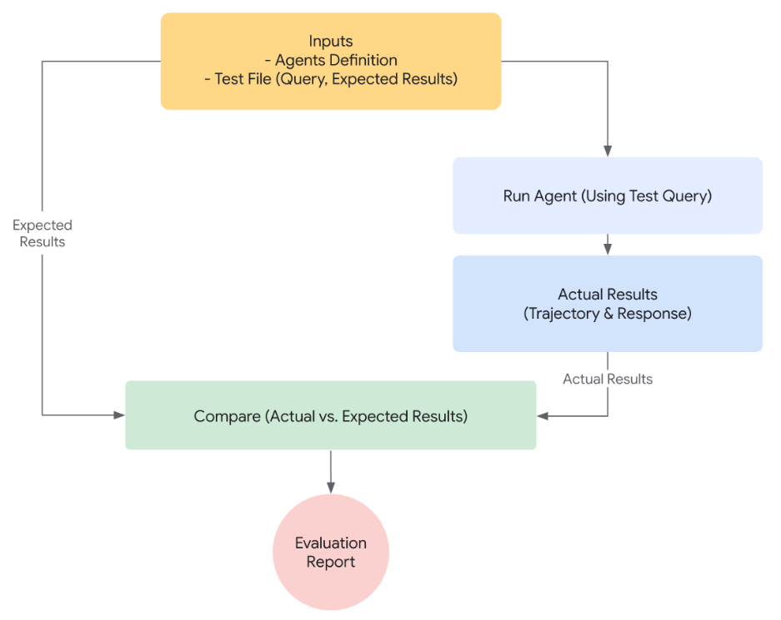
How evaluation works with ADK https://google.github.io/adk-docs/evaluate/#how-evaluation-works-with-the-adk

First approach: Using a Test file

This approach involves creating individual test files, each representing a single, simple agent-model interaction (a session with multiple turns). It's most effective during active agent development, serving as a form of unit testing.

- User content -> query
- Expected intermediate tool use trajectory -> tool calls for the query to respond
- Expected intermediate agent response
- Final response

Second approach: Using an EvalSet file

The evalset approach utilizes a dedicated dataset called an "evalset" for evaluating agent-model interactions.

An evalset file contains multiple "evals," each representing a distinct session. Each eval consists of one or more "turns," which include the user query, expected tool use, expected intermediate agent responses, and a reference response. These fields have the same meaning as they do in the test file approach.

Evaluation criteria
- tool_trajectory_avg_score: Exact match of tool call trajectory.
- response_match_score: ROUGE-1 similarity to reference response.
- final_response_match_v2: LLM-judged semantic match to a reference response.
- rubric_based_final_response_quality_v1: LLM-judged final response quality based on custom rubrics.
- rubric_based_tool_use_quality_v1: LLM-judged tool usage quality based on custom rubrics.
- hallucinations_v1: LLM-judged groundedness of agent response against context.
- safety_v1: Safety/harmlessness of agent response.
How to run evaluation
- Web-based UI (adk web): Evaluate agents interactively through a web-based interface.
- Programmatically (pytest): Integrate evaluation into your testing pipeline using pytest and test files.
- Command Line Interface (adk eval): Run evaluations on an existing evaluation set file directly from the command line.
ADK Web UI - https://github.com/google/adk-web
- AG-UI (Agent-User Interaction Protocol) -> how AI agents connect to user-facing applications. https://github.com/ag-ui-protocol/ag-ui
- CopilotKit -> https://docs.copilotkit.ai/, https://github.com/CopilotKit/CopilotKit
Agent2Agent (A2A) protocol
The A2A protocol is an open standard that enables seamless communication and collaboration between AI agents.
Its primary purpose is to move from single, monolithic agents to distributed, interoperable multi-agent systems where specialized agents can delegate tasks to one another, much like services communicate in a microservices architecture.

A2A Architecture and Components
A2A uses a secure, web-standardized architecture based on the Client-Server model and JSON-RPC over HTTP(S).
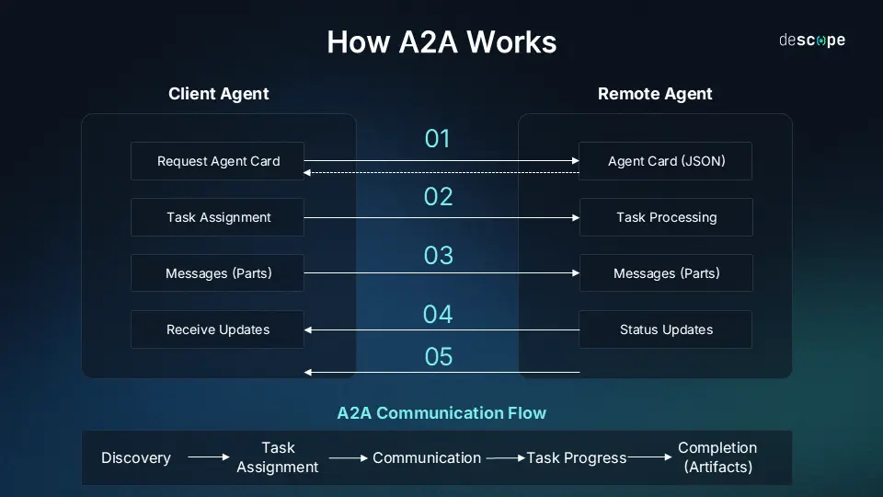
Phase 1: Discovery
Step | Action | Description
01 | Client Agent: Request Agent Card → Remote Agent: Agent Card (JSON) | The Client Agent initiates the process by sending a request to the Remote Agent's well-known discovery endpoint (e.g., /.well-known/agent.json). The Remote Agent responds with its Agent Card, a JSON file detailing its capabilities (skills), service URL, and authentication requirements. This allows the Client to understand what tasks the Remote Agent can perform.

Phase 2: Task assignment
Step | Action | Description
02 | Client Agent: Task Assignment → Remote Agent: Task Processing | The Client Agent, having verified the Remote Agent's capabilities, sends a JSON-RPC request to the Remote Agent's service endpoint. This request is packaged as a Task, which is the formal unit of work, defining the specific action and any required input parameters. The Remote Agent accepts the task and begins processing its specialized logic.
Phase 3: Communication and completion
Step | Action | Description
03 | Client Agent ←→ Remote Agent: Messages (Parts) | This represents the multi-turn, asynchronous communication during the task execution. Agents exchange Messages containing small units of content called Parts (text, structured data, files). This step allows for clarification questions, providing missing inputs, or sending intermediate conversational updates.
04 | Client Agent: Receive Updates ← Remote Agent: Status Updates | For long-running or complex tasks, the Remote Agent periodically sends Status Updates (e.g., Working, Waiting for Input, 90% Complete) to the Client Agent. This is often implemented via streaming or polling to provide visibility into the Task Progress.
05 | Client Agent ← Remote Agent: Completion (Artifacts) | Once the processing is finished, the Remote Agent sends the final result, typically packaged as one or more Artifacts (immutable output data like a generated report, image, or the final structured answer), signaling Completion of the Task.

Component | Role | Description
A2A Server (Remote Agent) | The Responder/Executor | The agent that exposes an A2A-compliant HTTP endpoint. It receives tasks, executes the requested business logic (its 'skill'), and manages the task lifecycle.
A2A Client (Client Agent) | The Initiator/Orchestrator | An application, service, or another agent that initiates a request to a remote A2A Server. It acts as the orchestrator, delegating sub-tasks.
Agent Card | The Metadata/Discovery | A standardized JSON file (similar to a model card or an OpenAPI spec) served at a well-known endpoint (/.well-known/agent.json). It describes the agent's name, description, A2A endpoint URL, supported capabilities (skills), and authentication requirements.
Task | The Unit of Work | The fundamental, stateful container for the work being requested. It has a unique ID and progresses through a lifecycle (e.g., submitted, working, completed, failed), allowing for long-running, asynchronous collaboration.
Message & Part | The Data Carriers | Message represents a single exchange in the conversation. Part is the smallest content unit within a message or artifact (e.g., TextPart, FilePart, DataPart for structured JSON).
Artifact | Output/ response | Delivers concrete results of an agent’s work, ensuring structured and retrievable outputs

How HayStack handles Heavy RAG systems

1. YAML Serialization for Pipeline Architecture
Haystack's ability to serialize the entire RAG workflow is a critical feature for production environments.
- Feature: Haystack allows the complete structure, components, and connections of an indexing or query pipeline (the DAG) to be exported to and loaded from a YAML file.
- Reason for Heavy RAG:
  - Version Control & Collaboration: This allows you to version control the architecture of your RAG system directly in Git, just like code. This is essential for large teams running experiments and ensuring the production pipeline is exactly the same as the one that was tested.
  - Deployment Agnosticism: The YAML file can be loaded and deployed anywhere (Kubernetes, AWS SageMaker, etc.) without running the Python construction code, simplifying Kubernetes-native deployments and horizontal scaling, which are mandatory for heavy RAG workloads.

2. Explicit Multi-Stage RAG Control (The Pipeline DAG)
While other frameworks can chain steps, Haystack's foundational architecture is designed as a Directed Acyclic Graph (DAG), providing built-in features for complex, multi-stage RAG flows.
- Feature: The pipeline's DAG structure allows developers to define complex, non-linear control flows directly within the RAG process, including:
  - Re-Ranking Components: Haystack natively and easily integrates dedicated Ranker components (e.g., cross-encoder models) after the initial retriever but before the generator. This two-stage retrieval drastically improves precision and is essential when searching through millions of documents.
  - Branching/Routing: You can easily add a Router component to send queries to different sub-pipelines or Document Stores based on the query's classification (e.g., route "HR" questions to the HR-VectorStore and "IT" questions to the IT-VectorStore). This prevents unnecessary retrieval costs and improves domain-specific accuracy.
- Reason for Heavy RAG: This explicit control allows for optimizing the most expensive steps. By using a fast, high-recall retriever (e.g., BM25/hybrid) to fetch 50 documents, then passing only those 50 to a slower, high-precision re-ranker, you achieve maximum quality at a fraction of the cost of running a single, less refined retrieval model.

3. Production-Grade Evaluation Integration
Haystack is built with measurable performance and auditing as a core goal, making it ready for continuous improvement in production.
- Feature: Native integration with advanced RAG evaluation frameworks like RAGAS and DeepEval as standard components. You can add an Evaluator component directly into your pipeline.
- Reason for Heavy RAG: Scaling a RAG system requires measurable, auditable quality. This feature allows production teams to:
  - Continuous Benchmarking: Run automated evaluation sweeps against a ground truth dataset to measure metrics like Answer Relevancy and Context Precision.
  - A/B Testing: Compare the performance of Pipeline A (e.g., using BM25) vs. Pipeline B (e.g., using a Dense Retriever) directly within the framework, providing the data needed to justify the computational cost of heavier retrievers.

4. Tool Abstraction as RAG Components
Haystack's philosophy of making everything a component or a pipeline simplifies the use of RAG in agentic systems.
- Feature: Haystack's ComponentTool abstraction allows wrapping any component (a retriever, a ranker, or even an entire sub-pipeline) into a tool that an LLM agent can use.
- Reason for Heavy RAG: In a complex enterprise environment, an agent might need to call a highly customized RAG workflow. Haystack makes it easy to encapsulate that complexity. An Orchestrator Agent simply sees a single tool called ResearchTool, which internally executes a complex, optimized 5-step RAG pipeline to get the answer, abstracting the heavy lifting away from the LLM's reasoning loop.

